BEST PRACTICES
Energy conservation: The College have taken many steps to minimize energy consumption. These include:-
- Replacement of energy consuming tube light & bulb with energy saving CFL tubes & LED bulbs.
- Energy consumption in the hostel should be monitored by a committee which can successfully bring down power consumption by enlightening the inmates about the indispensability of energy saving.
- The Energy Conservation Club can conduct various programmes, discussions and campaigns to create an energy conserving mentality among the students.
- The college can foster an energy saving attitude among students and staff through various programmes, discussions and campaigns in association with GESCOM.
- College can also organize an inter departmental, power quiz for the students.
- ELECTRICAL AND ELECTRONICS ENGINEEING DEPATRMENT has conducted awareness program on “DEMAND SIDE MANEGMENT AND SAETY PRECAUTIONS OF ELETRIC SHOCK’’ on 4th and 5 ^{th} October 2019 in GUTTIGANUR village.
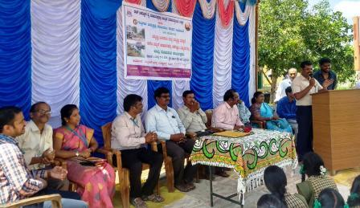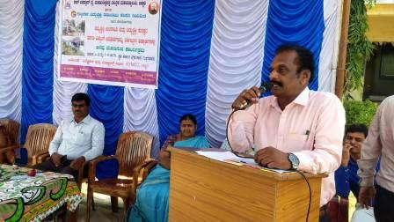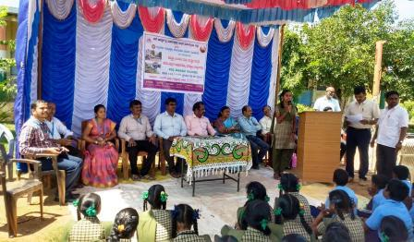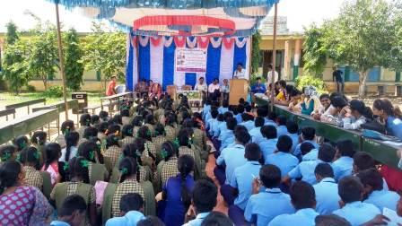

• We have even conducted many quiz related to many subjects like Renewable Energy Sources, Basic Electrical Engg, Analog Electronics, transmission and distribution and many other subjects through forms.
I've invited you to fill out a form:
RENEWABLE ENERGY QUIZ
THIS QUIZ IS CONDUCTED TO SPREAD AWARENESS ABOUT RENEWABLE ENERGY AND assess students’
levels of awareness regarding renewable energy sources.

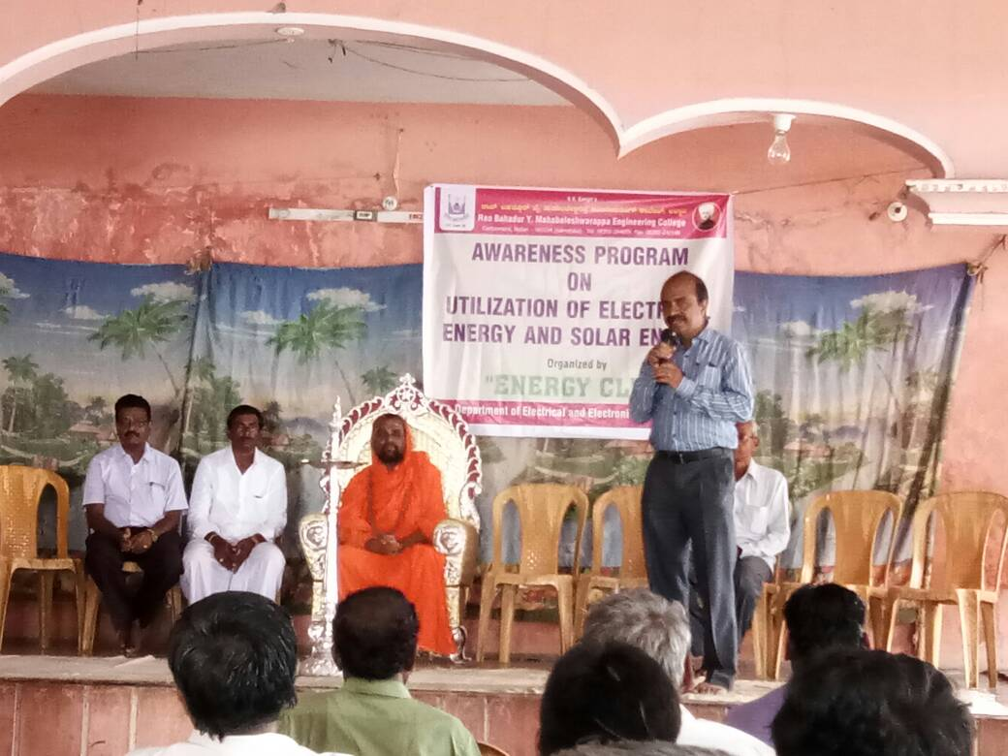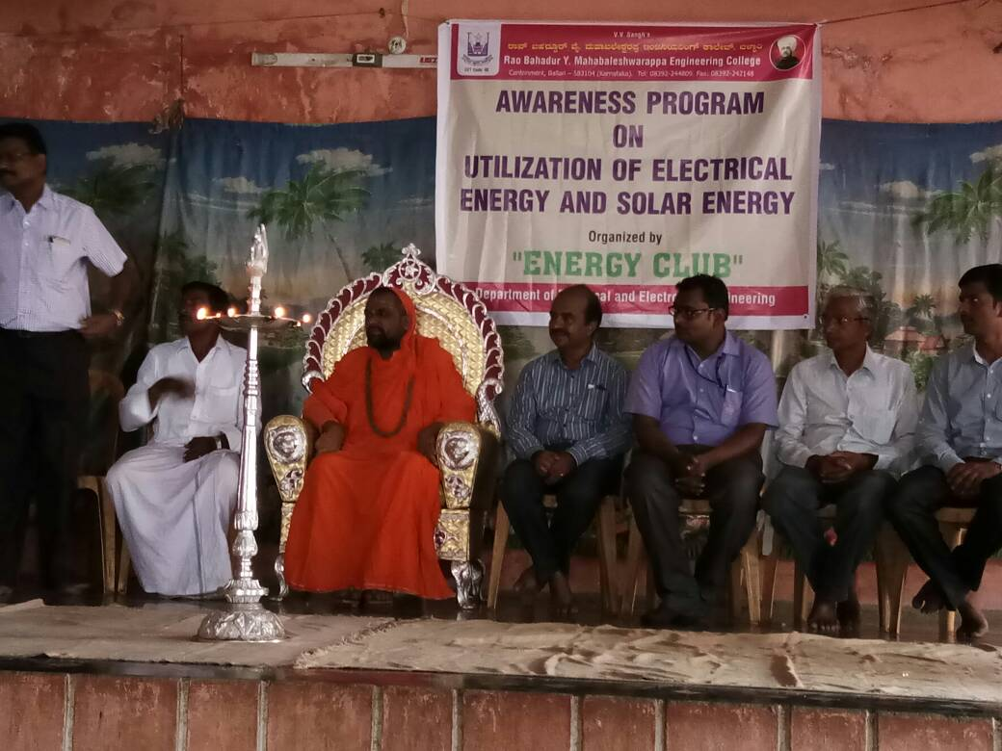
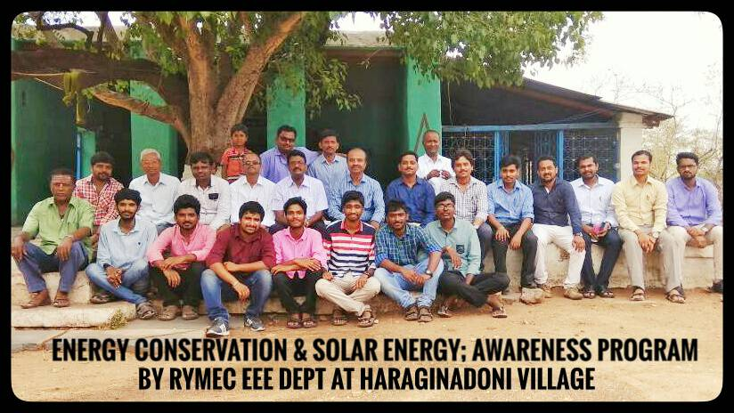
- ELECTRICAL AND ELECTRONICS ENGINEEING DEPATRMENT has conducted awareness program on “ENERGY CONSERVATION & SOLAR ENERGY’’ on in HARAGINADONI village.

BEST PRACTICES
Title of the Practice: Energy conservation and Energy Management

1. Title of the Best Practice: Introduction of LED Bulbs
2. Objective: To save energy and to make College campus eco-friendly.
3. Context: LED bulbs are 80% energy efficient compared to fluorescent bulbs. LEDs also make less wastage of energy than other conventional bulbs. LEDs however convert 95% of energy into light without only 5% being wasted as heat. Hence, using of LED bulbs saves energy and it is eco-friendly.
4. Practice: From last 4 years, LED bulbs are used in College and saving energy, thereby sensitizing or making aware the students and teacher community about energy saving.
5. Outcome of the Best Practice: Reduced the electricity bill of the College and saving the energy

Best Practices:-
To reduce the consumption of energy without compromising on quality and to set an example in the field of Energy Conservation, in accordance with the national objectives.
THE PRACTICE
Rooms have ample windows and wide doors for optimal utilization of natural light. SAVE ELECTRICITY campaigns are conducted throughout the academic year. Student volunteers of LEAD team have put up posters near the switch boards of classrooms urging users to switch off lights and fans on their way out.
USE OF LED LIGHTING: In a concerted move, traditional lights which consume a greater amount for power have been substituted by LED’S in the library and all corridors of the old block.
Dedicated work by the volunteers has ensured that students themselves switch off lights and fans when they move out of rooms, establishing a culture of energy conservation.

Title of the Practice: Use of Non-conventional Source of Energy
Objectives of the Practice:
The college is increasingly relying on the use of non-conventional source of energy by installing Solar Photovoltaic Panels. This also serves the objective to encourage our youth to understand the importance of energy conservation and more use of green energy.
Context of the practice:
Conventional source of energy are scarce and depleting day by day. The increasing electricity bills also require that alternative source of energy ought to be explored.
- The Practice:
The College has made a big stride in this desirable direction by harnessing solar energy. Solar panels have been installed on the roof tops of different buildings i.e. Arts Block, Library Building, Boys Hostel and Science Block having capacity of 28kw, 6 kw, 5kw and another 5kw respectively.
- Evidences of success:
It is estimated that roughly 25 – 40 percent electricity consumption of the college will be fulfilled by this arrangement. The use of solar energy has resulted into substantial reduction of electricity bill. The college which was paying a hefty amount earlier is now paying only the fixed meter rent.
- Problems and Prospect:
Further funds are required to augment the existing facility. Relying more on alternative source of energy will help us to make this planet more sustainable.

NEW
1. Title of the practice: Energy conservation and Energy Audit
2. Objective of the practice:
Objective of the Energy conservation and Energy audit practice is to encourage use of alternative source of energy. The Jiwaji University has established. Solar technology to meet its energy demands as much as possible in a green manner. This initiative has helped theUniversity in reducing dependency on conventional sources of energy for meeting their energy requirements and increasing its dependency on renewable energy resources.
Solar energy plays crucial rule in this initiative. Solar cell panels, Solar heaters, Solar lightning and solar energy-based equipment are used. Photoelectric effect is the underlying principle of working of Solar based electricity equipment.
3. The Context:
Major contextual features for making energy conservation initiative successful are the space selection for capturing solar energy. It is to be ensured that space for solar equipment is such that it receives ample amount of Sunlight without any hindrance from nearby buildings and trees. Second important feature of the initiative is to select the lab equipment that are energy efficient and can be integrated to the solar cell panels. e.g. Weather station at School of Studies in Environmental Science, it uses solar cell panels to monitor weather parameters. For the Energy auditing, School of Studies in Environmental Science is coordinating with the various Departments of Jiwaji University and its campus to audit them time to time. Ensuring maintenance of solar equipment is indispensable to the project as they are the crucial for energy conservation. School of Studies in Environmental Science rely on Solar equipment considerably as its uses Solar Weather forecasting station, solar panels and solar lightning in garden.

